1. Click on **Window > Package Manager**
2. Dock it next to the game tab



1. Click on **Packages: In Project** and select **Unity Registry**

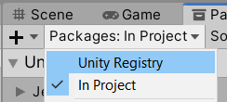

1. Look for **Terrain** (mine wasn’t in here) click on **Edit > Project Settings**
2. Find **Package Manager**
3. Find **Enable Preview Packages**

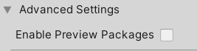

1. Click on it and **click I Understand**. Close the Project Settings.
2. **Terrain Tools** should now be available. Find it and **Install** it.
3. Clear any errors you have
4. Click on your **Terrain** and select the Paintbrush tool again and you should now have way more options

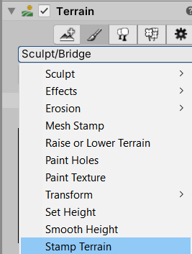

1. Lets play around with Sculpt/Bridge. If you hold CTRL and select a starting point then select a 2nd point it will create a bridge.

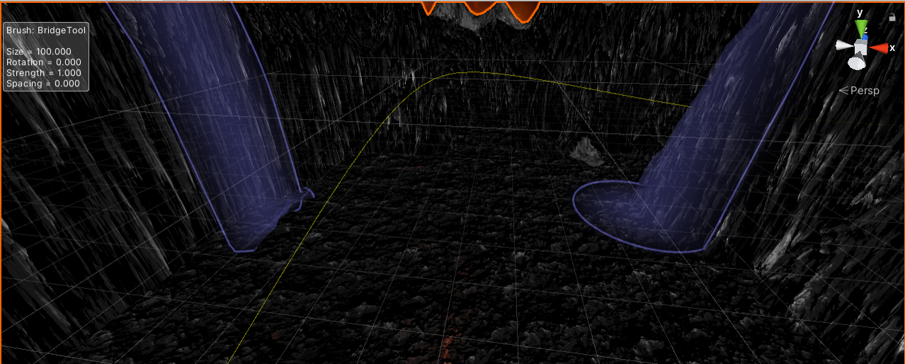

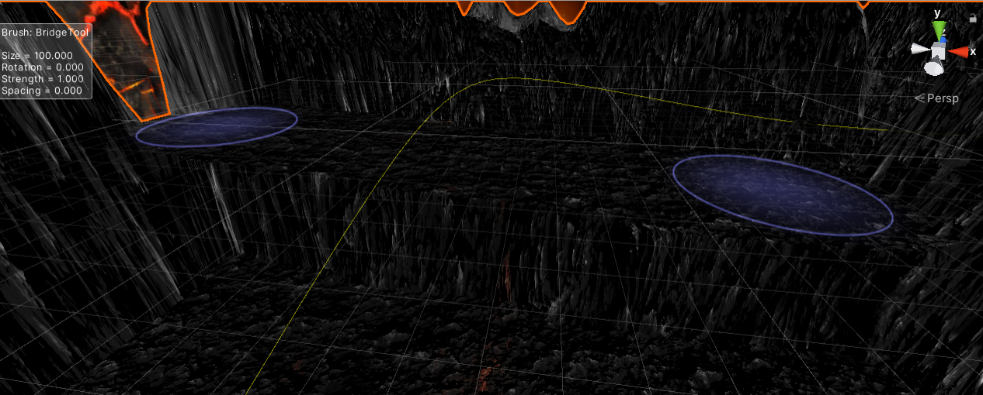

1. Select Sculpt/Clone
2. Hold CTRL and select a point. It will close this terrain. It kind of works like Photoshop clone stamp tool.

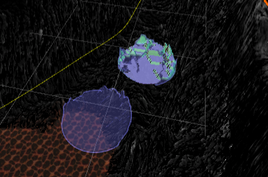 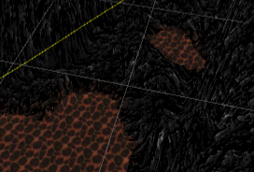

1. Select **Erosion/Wind**. You can see the direction the wind is blowing. You can change this with **Brush Rotation**. It will carve out this channel mimicking wind erosion.

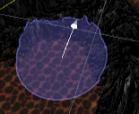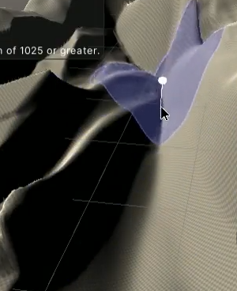

1. Jitter controls how much randomness the Brush randomly changes size by. 1 being completely random.

Hotkeys

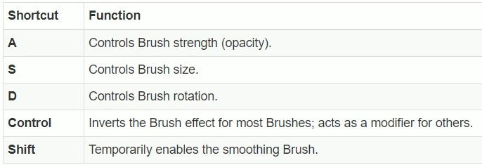

1. You can also select Sculpt/Noise to add variance to your terrain.
2. Use **Smooth Height** to smooth out the terrain. it takes the high point and low point to try and create a smooth transition.
3. **Transform/Pinch** will squeeze together your hills making them pointy

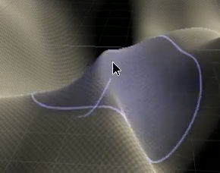

1. **Transform/Smudge** will move terrain and smudge it across the map.
2. **Transform/Twist** will create spiral like terrain. It will look unnatural so you **Smooth Height** to make it more natural

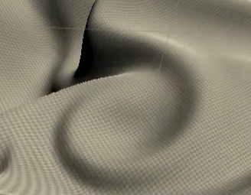

1. You can use **Paint Holes** to tear holes in the terrain. Useful to fly though something.

**Challenge:** Play around with the tools and see what you can create.